RYAN FREEL, PARTNER
Houston, TX, USA

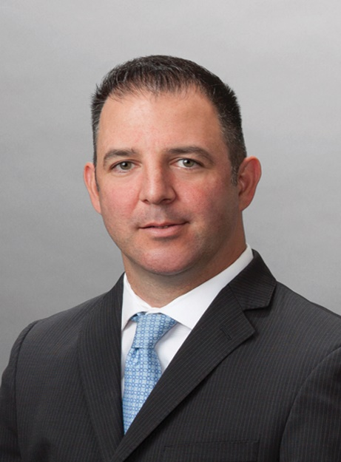

Ryan leverages the experience he has gained in various roles throughout the firm to provide clients with comprehensive worldwide immigration solutions. Ryan began his career with Fragomen as an Associate in 1999 and has since served as a Senior Client Services Manager within the Asia Pacific region and Director of International Alliances and Client Services. In these roles, he has managed the firm’s U.S.-based global business visa, passport, document services and consular teams; managed the inception and ongoing operational development of our Singapore office; and led the firm’s Local Advisor network and its expansion efforts in EMEA. He also undertook a secondment to a leading oil field services company as the Immigration Program Lead, where he successfully implemented and co-managed a comprehensive global immigration program.
Ryan has also served as the Director of Global Immigration Services at a well-known relocation company and Vice President of Global Operations at a global immigration consulting firm. Ryan is currently based in the firm’s Houston office, where he manages client relationships in the oil and gas as well as technology industries.
Ryan received his J.D. from University of Miami School of Law in 1999 and his B.A., cum laude, from Salve Regina University in 1996.

CYNTHIA SHEARN, PARTNER
Chicago, IL, USA

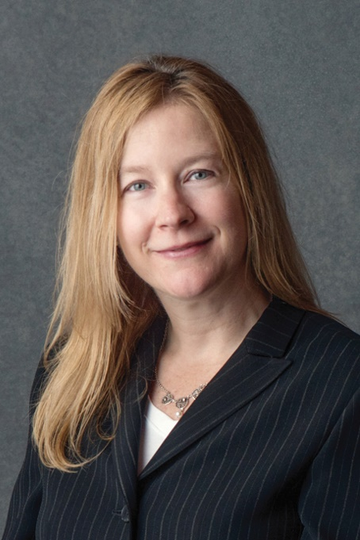

Cindy is the Managing Partner of the firm’s Chicago office. Cindy joined the firm in 1997, and since that time, she has practiced exclusively in the area of corporate U.S. immigration law. Prior to joining the firm, she focused on international and human rights law as evidenced by her positions at the Interparliamentary Union and the United Nations’ International Labor Organization, both located in Geneva, Switzerland. Cindy currently represents multinational corporate clients in such industries as management and technology consulting, logistics and supply chain, transportation, pharmaceuticals and biotechnology. She advises clients on developing and maintaining successful immigration programs in an evolving environment. Her practice in U.S. corporate immigration law includes nonimmigrant visas, permanent residence, and I-9 and Labor Condition Application (LCA) compliance.
Cindy earned her Juris Doctor from American University, Washington College of Law and Bachelor of Arts from Boston University.

Debbie Convery, GMS, SPHR
Director of Global Mobility- Peloton Interactive

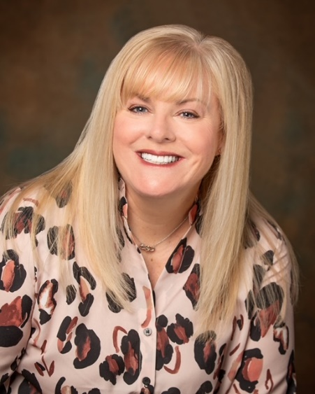
Debbie graduated from George Fox University with a degree in Management and Organizational Leadership and is a certified Sr. Professional of Human Resources (SPHR) and a Global Mobility Specialist (GMS). Debbie is actively involved in the Mobility community. She is an Advisory Board Member for the Relocation Directors Council and Global Mobility Executive and has served on the Pacific Northwest Relocation Council and the Portland Relocation Council board of directors. Debbie is currently the President of PRC.

Christopher Chalk
Global Mobility Manager- Coca Cola
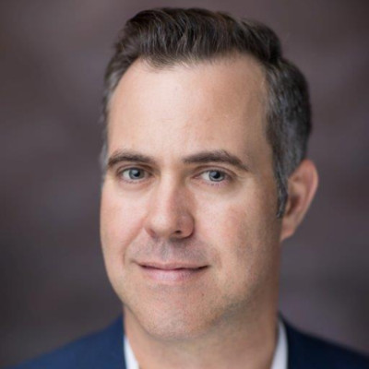
Chris has a rich history in the global mobility industry, having been on both the partner and corporate side of the table. His career has taken him in many directions, from business development, mortgage services, and onto companies like Doosan, Siemens, and now Coca-Cola. As the Global Mobility Manager, he leads the Global Mobility Account Manager Team for all cross-border activity, and the Global Mobility systems and business intelligence team.

William Taylor
Head of Partnerships, Relocity

William Taylor is Head of Partnerships at Relocity, a technology company that is revolutionizing destination services and enhancing the employee experience. He has over 20 years of experience in Global Mobility, having held leadership roles on both the corporate and supplier side of the industry

Prior to joining Relocity, William was Head of Global Mobility at Adobe. He is a licensed immigration attorney and practiced law at a distinguished, global immigration firm.

William served as President, Bay Area Mobility Management (BAMM) from 2016-2017, and served on the BAMM Board for eight years. He is a well-recognized leader in the Global Mobility industry and a frequent speaker at industry events, including Worldwide ERC, American Immigration Lawyers Association (AILA), Atlas Forum, Forum for Expatriate Management, Bay Area Mobility Management, HR West (NCHRA), and many regional Global Mobility organizations. William has been recognized for his contributions to the industry with a Meritorious Service Award from the Worldwide ERC.

